Text 1.

Read the following text and answer the questions:

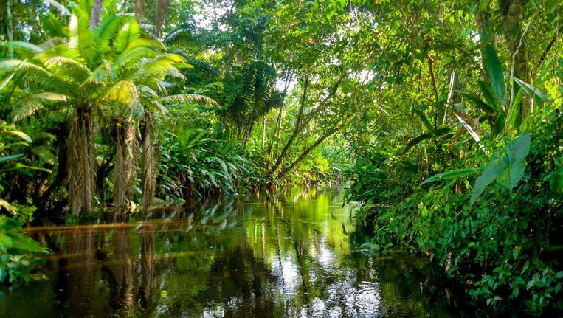
The Amazon forest covers five million square kilometres, an area as big as the whole of Europe excluding Russia. It contains one third of the world’s trees. However, the trees are disappearing. By 1974, a quarter of the forest had already been cut down. In the following year, 1975, four per cent of the remaining trees went. If the destruction of the forest continues at the same rate, there will be nothing left in a few years.

Scientists say that the disappearance of trees is already causing changes in the climate. In Peru, there is less snow than before on the high peaks of the Andes mountains. In Bolivia there is very little rain.

What will happen if more of the Amazon forest is cut down? According to climatologists if the Amazon forest disappears, there will be less oxygen and it will be difficult for us to breathe, the temperature will rise, the ice-caps at the North and the South poles will melt. Even the sea level will rise. Therefore, seaside cities will be flooded.

Scientists do not agree about the calculations which can be done in different ways with different results. But all the scientists agree that if we destroy the Amazon forest, it will be an environmental suicide. Life on earth will become difficult, and it may become impossible.

- Give a title to the text:
____________________________________________________________________________________________________________________________
- Say whether the following statements are true or false:
- The Amazon forest is bigger than Europe.
- It contains most of the world’s trees.
- Deforestation leads to climate change.
- If the Amazon forest is destroyed, the coastal towns will be under water.

- Answer the following questions about the text:
- How big is the Amazon forest?
- Why is the Amazon forest so important?
- What will happen if it ever disappears?

Text 2. Friends of the Earth:

- Gap fill exercise: Choose the correct words from the box to complete the sentences.

acid – change – endangered – environmental – layer –
ozone – polluted – rainforests – reduction – renewable

Friends of the Earth is the world’s largest international network of (1) ……………… Groups represented in 68 countries. In the UK, it was the first organization to campaign to save whales, (2) …………………………………….. species and tropical (3) …………………………………………. . Friends of the Earth also fought against (4) ………………………………………… rain, (5) …………………………………… depletion and climate (6) …………………………………………………. .
The organization’s present campaigns cover many more issues, such as protecting the wildlife and the countryside and cutting air pollution. They promote waste (7) ……………………………………………… and cleaning up of (8) ……………………… Rivers. They also campaign for the reduction of traffic levels and the improvement of public transport.
They lobby politicians and political parties to protect the ozone (9) …………………… and control dangerous chemicals. Their objectives also include promoting energy efficiency and (10) ………………………… energy.

Text 3; SHOCKING FACTS ABOUT RUBBISH

DID YOU KNOW THAT …………
- The average person generates about 2 kilos of rubbish every day and produces about 1.5 tonnes of solid waste per year in the US.
- In 2009, Americans produced enough trash to circle the Earth 24 times.
- Over 75% of waste is recyclable, but Americans only recycle about 30% of it.
- Americans are responsible for 21.5 million tons of food waste each year. If we composted that wasted food, it would reduce the same amount of greenhouse gas as taking 2 million cars off the road.
- Recycling one aluminium can saves enough energy to listen to a full album on your iPod. Recycling 100 cans will light your bedroom for two whole weeks.
- Recycling aluminium cans saves 95% of the energy used to make cans from new material.
- Americans discard 25,000,000 plastic bottles every hour.
- Over 87% of Americans have recycling programmes near their homes or workplaces.
- In 2009, Americans threw away almost 9 million tons of glass. That means it filled enough container trucks to stretch from New York to Los Angeles and back.
- Since 1990 paper recycling has increased by 89% in the US.
- If every American recycles just one-tenth of their newspapers, we will save about 25 million trees each year and reduce deforestation.

- Every year, Americans throw away enough writing and office paper to build a wall that is four metres high from New York to Los Angeles.

1. According to the passage, are the following statements are true or false? Write ‘T’ for true and ‘F’ for false

- 25 million bottles are thrown away per day in the US.

- Recycling aluminium is an good way of saving electricity

- Leftover food can be used to make soil.

- By recycling newspapers, fewer trees will be cut down.

- It is not easy for most Americans to recycle because many of them do not live or work near recycling bins.

